BRAC University (Department of Computer Science and Engineering)

CSE 221 (Algorithms) for Spring 2025 Semester

Quiz 4
Student ID: Full Marks: 20
Section:
Name: Duration: 25 minutes

1.
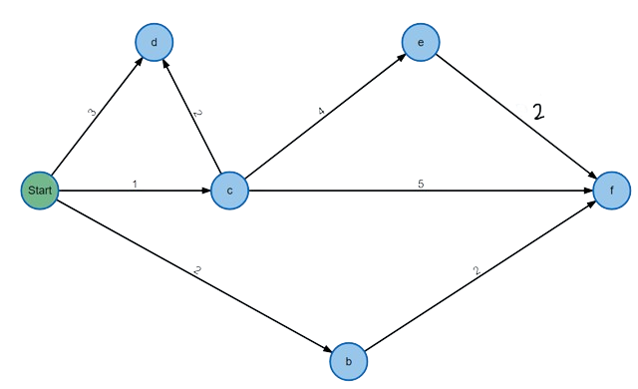
The start node is a.
Perform Dijkstra’s algorithm on the above graph and fill up the following table with the distance values of each vertex. In case of a choice between the same minimum nodes, always choose the alphabetically smallest node.

The first row has been completed for your convenience. (Marks: 8)

Iteration | ExtractMin() | A | B | C | D | E | F
 |  | 0 | ∞ | ∞ | ∞ | ∞ | ∞
1 | A | 0 | 2 | 1 | 3 | ∞ | ∞
2
3
4
5
6

2. You realize that you forgot some of your belongings in some tunnels. Hence, you want to
construct the MST such that those tunnels are always included no matter how dangerous
they are.
Formally, you have an undirected weighted graph with some edges marked as “important”
and you need to propose a modification to Kruskal’s algorithm such that you can find the
MST that always includes those important edges (even if it increases the total cost).
For simplicity, you can assume the important edges/tunnels do not create any cycles. Look
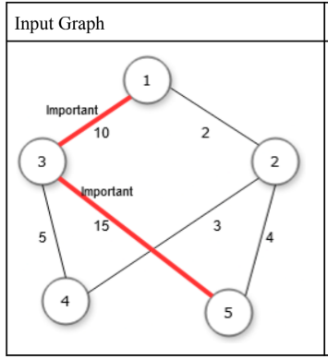
at the example input graph below.

i) Write down what modifications you will make to original Kruskal’s algorithms pseudocode to find the modified MST. (Marks: 2)
ii) find the modified MST from this graph. (Marks: 4)

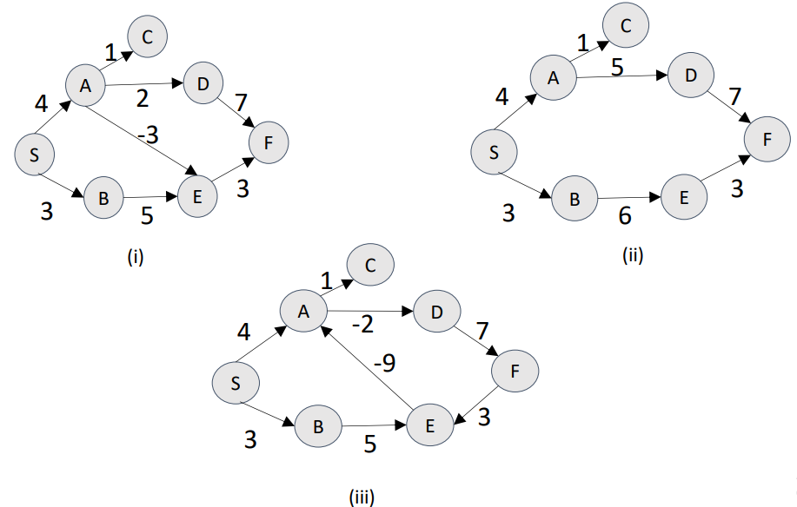

3.

For each graph write down whether single source shortest path exists or not. If it does not exist explain why. If it exists, determine which of the two algorithms between Dijkstra and Bellman-Ford is more appropriate to find shortest paths. (3 * 2 = 6 marks)

